Lidcombe Bowling Club

3 James St Lidcombe
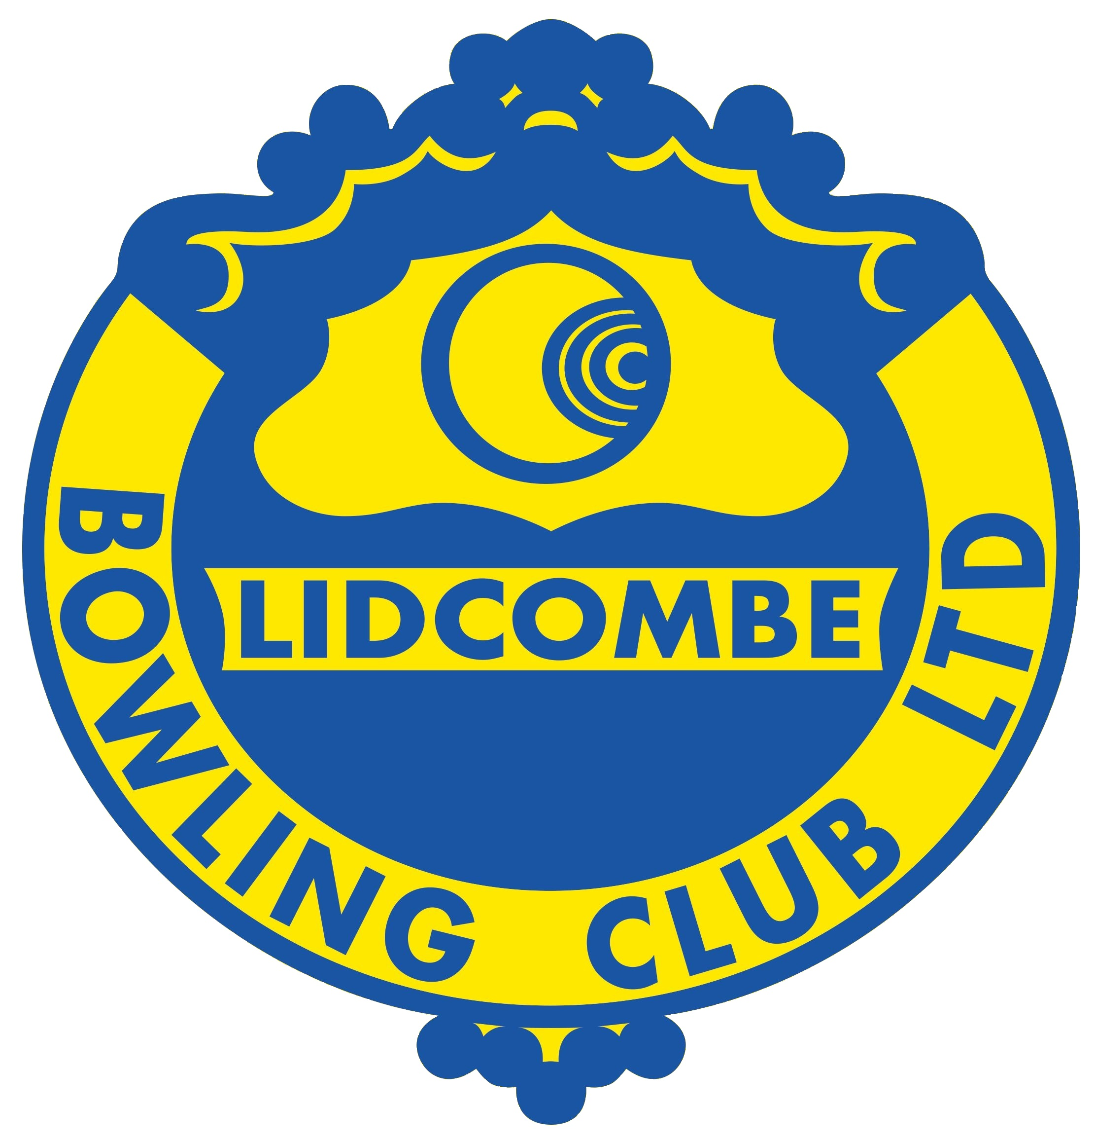

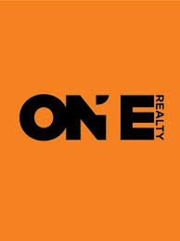
MEN’S GRADED TRIPLES

PRIZE MONEY $4,200

Qualifying | Saturday 4th November OR Sunday 5th November
Final | Saturday 11th November

For players graded 5-7
(a player’s 2023 or current grading)

Enquiries: David 0422 834 164 or Jim 0439 959 178
www.lidcombebowlingclub.com.au

Conditions: 8.45 am start
2 bowl triples - 4 games of 12 ends each day.
$120 per team, includes lunch.
Winners – $1,800, Prizes to 6th place, plus Best Margin prizes

Entries & Payment: Triples Tournament, Lidcombe Men’s Bowling Club, PO Box 56, Lidcombe NSW 1825
Email to: LidcombeBC@gmail.com
ANZ, BSB: 012357, Account: 4649 51971 (description must include skip’s surname)

Lidcombe Graded Triples 2023 – Entry Form

LEAD: CLUB: GRADE:

SECOND: CLUB: GRADE:

SKIP: CLUB: GRADE:

Preferred sectional play:  Sat 4th November OR  Sun 5th November

TEAM CONTACT NAME: PHONE:

ADDRESS (Email preferred):

