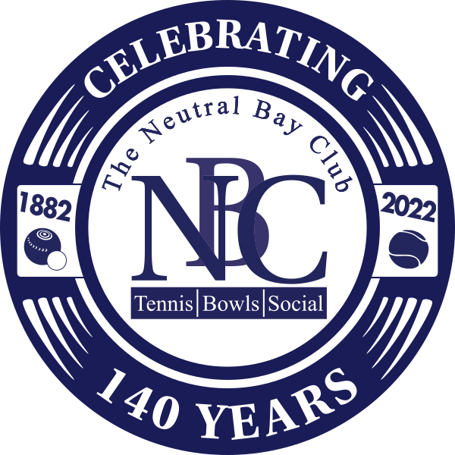
The Neutral Bay Club
3 Westleigh Street
Neutral Bay, NSW 2089
Ph: 02 9953 2066
Email: neutralbaypirates@gmail.com

22 April 2022

The Men’s Bowls Secretary.
Bowling Club

The Neutral Bay Club – est. 1882
PETER RUSSELL MEMORIAL TROPHY
71st ANNIVERSARY TOURNAMENT
PRIZE MONEY - $1875

Subject to COVID 19 restrictions, the Club plans to stage the 71st edition of this annual Tournament, the Peter Russell Memorial Trophy, which was established to foster goodwill between bowlers and has been played for since 1951.
This year’s edition holds even more significance, as it corresponds with the 140th anniversary of The Neutral Bay Club, the second oldest Licenced Club in New South Wales. The Club is adding additional sponsorship to this year’s tournament in acknowledgement of its special year and has contributed $1,000 for catering purposes.
The Peter Russell Memorial Trophy is a unique event as it is one of the few tournaments that is available for teams to compete, rather than individuals. One objective of this tournament is to provide the opportunity for participants to renew old acquaintances, also to form great new friendships and provide tough team competition unlike any other event in our area.
We cordially invite your club to enter in 2022 for this great trophy and prizemoney, under the conditions as set out below. Please note that some eligibility clauses and format changes have been made, in line with more contemporary bowls events in modern times.
Format
- Entry fee of $125 per team. Two bowls triples, a maximum of 5 players per team from each Club, any of whom may be interchanged at the completion of each game.
- Each team will comprise bowlers who competed in the 2021 NSW Bowls Association Sydney Pennant Competition (from your current club members), and who competed in at least one match between the grades of 4 and 7 inclusive.
- A maximum of 16 teams will compete and will be divided into 4 groups of four teams in each group. Each team will play three matches of ten ends per match, in a round robin format. No dead ends, the jack to be replaced on the “T”.
- The qualifying rounds of the competition will be played in two sessions: Saturday 16 July 2022, commencing 9.00am, and
Sunday 17 July 2022 commencing at 9.00am.
You may nominate your preference for Saturday or Sunday games and each Club’s request will be accommodated where possible. However, this may not always be possible and a team must be available to play when drawn.
Your team will be required to compete in only one of these two sessions (i.e either Saturday or Sunday).
- The winners in each group will return to play Semi Finals on Saturday 23 July 2022, commencing at 9.00am.
The draw for the Semi Finals will be as follows and played over 15 ends:
The Winner of Group 1 plays the Winner of Group 2.
The Winner of Group 3 plays the Winner of Group 4.
Lunch will follow. Afterwards, there will be a 15 end Final between the Semi Final winners, and a 15 end playoff for 3rd and 4th placings (between the losing Semi Finalists).
Scoring will be as follows: 2 points for a win; 1 point for a tied game; in the event of a points draw, a countback system will apply, based on the difference between the total number of ends won and the total number of ends lost, during a session of play. The team with the largest difference will progress.
- In the event of inclement weather, the Club may alter the conditions of play.
- Prize Money is First $1000 – Second $500 – Third $250 – Fourth $125

Other playing conditions and information:
Entries close on 31 May 2022 or earlier if the 16 team field is filled.
Depending on the number of entries, byes may be included.
Once the draw is available, we will advise the nominated person from each club.
The Neutral Bay Club will provide lunches for all players.
The winning club will hold the trophy for 12 months.
To enter this year’s event please complete and return the attached form by email to neutralbaypirates@gmail.com. There is no need to pay the entry fee at this time, we will contact you at the start of June with payment details.
We look forward to providing a warm welcome to your team at “The Bay”.

Greg Scott
Secretary, Men’s Bowls Section
Ph: 0416 246 111 Email: neutralbaypirates@gmail.com
The Peter Russell Memorial Trophy, 2022
Entry Form

Club name

Preferred date of sectional play (please tick)

16 July 2022 - Saturday
17 July 2022 - Sunday

Nominated contact person
Phone
Email
Date

Please return completed entry forms by email to neutralbaypirates@gmail.com.

Entries close on 31 May 2022 or earlier if the 16 team field is filled.

The Peter Russell Invitational Trophy

Peter Nicol Russell was a well known Sydney engineer who learnt to play bowls at the Neutral Bay Club in the 1940’s.
He so enjoyed the game and the company of the people he met, particularly when visiting or hosting other Clubs that upon his death he bequeathed to the Club a very impressive Trophy to be competed for each year by Clubs with which a friendship had been established with the Neutral Bay Club.
The competition was inaugurated in 1951, which makes it one of the oldest continuing tournaments on the North side of the Harbour.
The inscription on the Trophy sums it up succinctly “Bequeathed to Neutral Bay Club by the late Peter Nicol Russell” as a symbol of his appreciation of fellowship of bowls and to foster a continuance of that spirit between the Neutral Bay Club and adjoining Bowling Clubs within the Northern Suburbs District.

