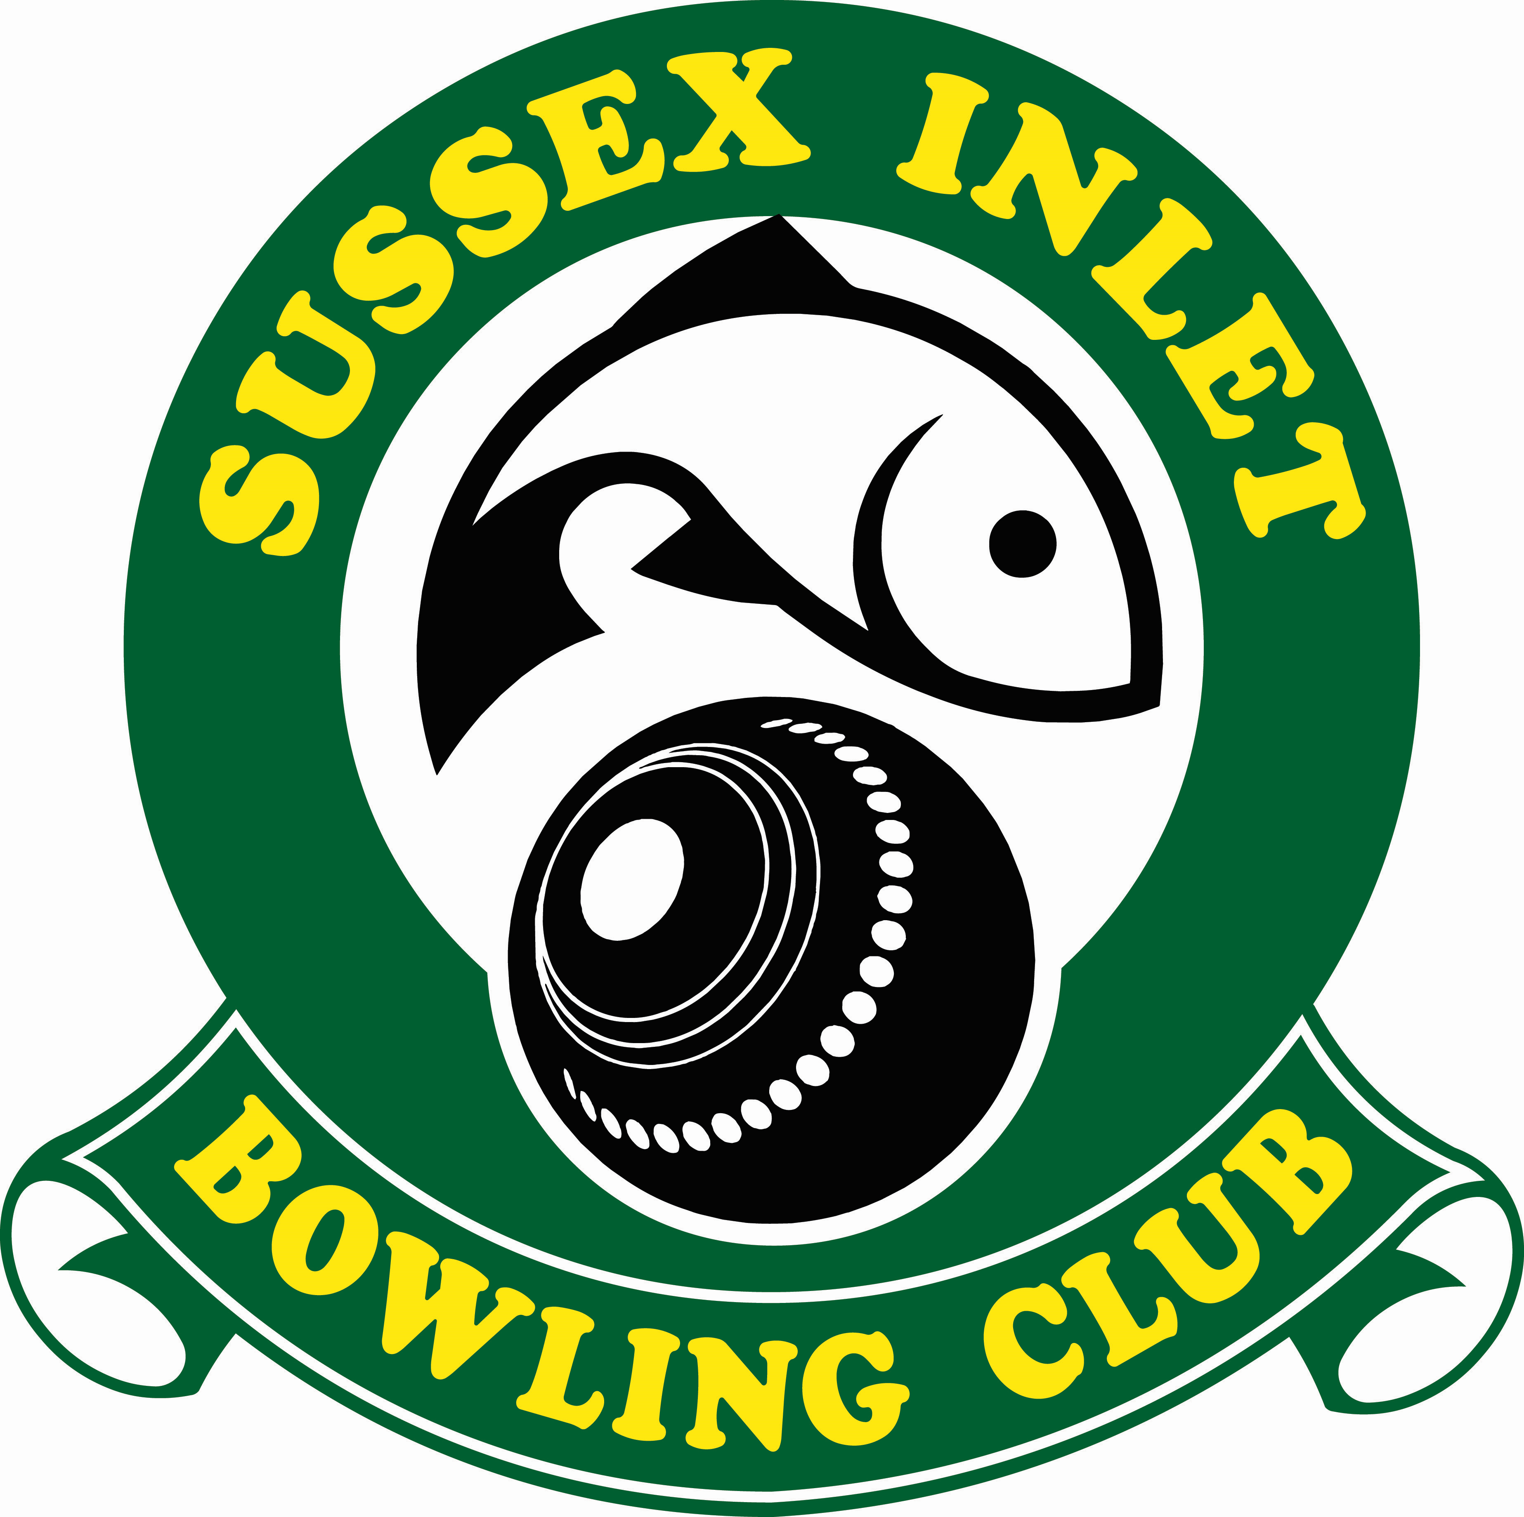
SUSSEX INLET BOWLING CLUB LTD

Duty Statement: Part-time Bowls Coordinator
Position Overview: The Part-time Bowls Coordinator is responsible for promoting and coordinating all aspects of lawn bowls activities within the club. They will oversee the organisation of various bowls events, manage club coaches and umpires, ensure compliance with regulations, and facilitate community engagement initiatives.
Key Responsibilities:
- Promotion of Lawn Bowls:
  - Actively promote lawn bowls activities within the club and the wider community.
  - Encourage participation in zone, district, state, club, and social bowls events.
- Program Coordination:
  - Develop and implement the annual bowls program.
  - Ensure the smooth running of open gender, single gender, and social bowls events on a daily basis.
- Compliance and Regulation:
  - Coordinate club coaches, umpires, and committees to ensure compliance with Bowls NSW regulations.
  - Ensure adherence to any relevant programs mandated by Sussex Inlet Bowling Club Ltd.
- Pennant Selection:
  - Coordinate the selection committees for both open and single gender pennant teams.
- Tournament Management:
  - Organise and oversee the delivery of open and single gender tournaments.
- Community Engagement:
  - Plan and execute community engagement activations, such as bowls parties, Try Bowls events, and school programs.
- Greens Management:
  - Liaise with the Greens Contractor to schedule and coordinate the use of the green space.
- Other Duties:
  - Undertake any additional duties as directed by the General Manager or their delegate, which may include working hours during service and bowls functions.
Qualifications and Skills:
- Strong interpersonal and communication skills.
- Knowledge of lawn bowls rules and regulations preferred.
- Organisational abilities with attention to detail.
- Ability to work independently and as part of a team.
- Flexibility to work evenings and weekends as required.
- Previous experience in a similar role or within the lawn bowls community is advantageous.
- Work with Children Certificate
- 1st Aid Certificate
- Basis Computer Skills
The Bowls Coordinator plays a vital role in fostering a vibrant and inclusive bowls community within the club, contributing to its overall success and growth.

