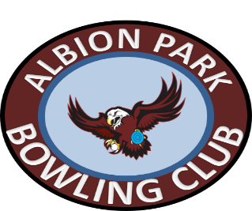

Albion Park Bowls Operations Manager

Albion Park Bowling Club is situated in Shellharbour 22km south of Wollongong in an area which has seen exceptional growth in recent years. We are looking for passionate & organised applicant for this diverse position.
Reporting to the General Manager and working alongside bowls committees this role encompasses all facets of a bowls coordinator role with the opportunity to gain experience in club management & operations.
Key responsibilities:
- Oversee the bowls program, including but not limited to; Barefoot & Participation Programs, Tournaments, Events, Club Championship, Pennants and Social Bowls.
- Promotion of bowls and events via social media
- Work alongside the GM to boost overall participation and facility usage
- Meet membership recruitment & retention KPI’s
- Coordinate with club coaches, umpires & committees
- Attend monthly meetings
- Achieve sponsorship targets
The right applicant will be given a wide range of discretion in structuring the role and will ideally possess the following skills:
- Use of computer software to manage the bowls program
- Social media skills
- RSA & RCG
- Experience working with boards & committees
- Club or Advanced Coaching Certification

Applications close 30th November 2021
If you would like more information or to apply for role would like please contact General Manager, Stan Miholic apbcmr@exemail.com.au

